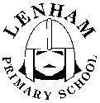

Lenham Primary School
Relationships & Sex Education Policy
April 2017

Named member of staff: Sarah Howell Named Governor: Ceri Norey

Introduction

At Lenham Primary School, we believe that Relationships & Sex Education (RSE) goes beyond the biological knowledge of sexual reproduction. As a subject, it also has moral, legal, cultural and ethnic dimensions, and links to the school’s promotion of health, well-being and informed decision-making, to understand and manage their emotions and to experience healthy, safe relationships with others.

The policy will be shared with staff, parents, pupils and governors, and will be available, along with other policies on the school’s website:

Aims & Objectives

We aim for the RSE curriculum to be a spiral curriculum continuous and age-appropriate during the pupils’ time at Lenham Primary School.

We aim to contribute and promote the spiritual, moral, cultural, mental and physical development of our children. It will prepare them for opportunities, responsibilities and experiences of adult life.

Throughout our teaching, we hope to enable children to learn the significance of stable relationships. We aim to encourage children to develop loving, caring, honest relationships and respect and value others.

We aim to inform the children about the physical and emotional changes of the male and female bodies throughout puberty, and encourage them to ask questions. We will also provide reassurance that puberty is normal and acceptable, yet changes and timescales are unique. Lots of children start puberty before they leave primary school so it is important that all pupils know what to expect before it happens.

We aim to help young people build their self-esteem in order to respect themselves and others and move, with confidence, from childhood through to adolescence, including social changes in puberty and positive and negative influences from friends.

We aim to provide the children with the knowledge of what happens during sexual intercourse, and that this can result in pregnancy. We also wish to encourage discussion and correct and misconceptions about sex, sexuality and same sex families. The school will challenge homophobia, biphobia and transphobia. We aim to provide the opportunity for children to reflect on their own attitudes and beliefs and those of their peers and others.

We will also emphasise respect for their own bodies and the importance of sexual activity being within a respectful, committed, long-term loving relationship. Pupils will be given accurate information and helped to develop skills to enable them to understand differences and develop an awareness of responsibility for themselves and for others and to understand self-esteem and the law connected to consent.

We aim to provide an environment where children can seek advice on sexual matters, including those that could be perceived as sexual abuse or exploitation. Pupils can recognise if other people make them feel uncomfortable or unsafe and can report abuse and get help. This links to the school’s proactive ethos on Safeguarding, including our use of the NSPCC PANTS rule and Share Aware resources.

Teaching & Learning Style

At Lenham Primary School, we use a variety of teaching and learning styles to aid RSE. Our main aim is to teach children to foster and develop caring relationships with others.

RSE supports, and is supported by the Science and PSHE curricula.

RSE has three main elements:
- Attitudes & Values: learning the importance of values, individual conscience and moral considerations; learning the value of family life, marriage and stable, loving relationships; learning the value of respect, love and care; exploring and understanding moral dilemmas; developing critical thinking as part of decision-making.
- Personal & Social Skills: learning to manage emotions and relationships confidently and sensitively; learning to develop self-respect and empathy for others; learning to make choices based on an understanding of difference with an absence of prejudice; developing an appreciation of the consequences of choices made; managing conflict; learning how to recognise and avoid exploitation and abuse.
- Knowledge & Understanding: learning and understanding the physical development at the appropriate stages; understanding human sexuality, reproduction, sexual health, emotions and relationships.

During sex education itself, Year 5 and 6 sometimes have worked in single sex groups, if the group has requested; have had opportunities to ask questions anonymously; set and abide by ground rules , following discussions in class about expected behaviour and confidentiality, and watch a DVD (currently, this is Channel 4’s ‘Living & Growing’, but this is subject to change. Distancing techniques are used, i.e. fictitious characters instead of real people are used. Other teaching methods include drama and circle time.
Prior to the showing of any DVD, parents are sent a letter, outlining the scheme of work and are invited to view the programmes and discuss any concerns with the class teacher. This provides the parent with a shared understanding from the school’s perspective, before approving the input, or deciding to withdraw their child. If a parent subsequently wishes to withdraw their child from the lessons, the parent is required to meet with the class teacher and the headteacher, in order to express their wishes. The parent may organise this meeting through the school office, as with any other meeting. We will support the parent in providing RSE for the pupil, at home. It should be noted that the Science curriculum element of RSE is statutory and that we will be unable to avert conversations between pupils and their peers at breaktimes.
Appropriate biological terms will be used, e.g. vagina, penis, clitoris etc. (See Appendix 2) The vocabulary links to Safeguarding, particularly the national priorities of Sexual Abuse, CSE and FGM.
Unacceptable language / behaviour will be challenged by the class teacher, by teaching the importance of learning and by referring back to the agreed ground rules. Parents of pupils who seem to be unable to cope with the lessons, will be spoken to and asked to complete the work at home with the child. Continual misbehaviour may mean the pupil is subsequently withdrawn from the remainder of the lessons.
Teachers have responsibility to ensure the safety and welfare of pupils and can reassure parents that teachers’ personal beliefs and attitudes will not influence the teaching of RSE at Lenham Primary School. All adults contributing to RSE are expected to work within the school’s values and ethos. The teaching of RSE always follows the school’s Safeguarding Policy. Staff are updated annually via Staff Development Meetings, or sooner if necessary / guidelines are altered.

Using school level data, we will ensure our RSE programme addresses the diverse needs of our pupils. The needs of all pupils will be met during RSE lessons, by differentiation or support.

As with all areas of the curriculum, it may be deemed worthwhile for a visitor to enhance the lessons. The calibre of the visitors will be vetted by staff, adhere to the school’s Code of Conduct, Safeguarding Practices and confidentiality.

RSE Curriculum Planning

RSE is only part of our Science and PSHE curricula. For details of the Science Curriculum, please refer to: https://www.gov.uk/government/publications/national-curriculum-in-england-science-programmes-of-study and the curriculum plans on our school website http://www.lenham.kent.sch.uk/ For details of the whole school plan for PSHE, please see appendices.

RSE is taught in all year groups. It will be age appropriate and will build on knowledge from year to year.

Contribution of RSE to Other Curriculum Areas

The skills that children develop in RSE are linked to, and can be applied to, every subject of the curriculum – especially developing relationships (on and off line), with others and informed decision-making.

Adults in the school are also aware that girls may begin menstruation when they are quite young. Disposal facilities are available in the toilets the girls use and there are some sanitary products available, in an emergency, in school. In order to ensure the girls feel supported at school, parents are asked to share information with school.

Teaching RSE to Children with SEN

Children’s needs can be met through differentiating the lesson in many days, e.g. through enlarged texts, or on different coloured backgrounds, changing the size of the group for discussions, through IT, through support and pre-teaching etc. We aim to make the lessons accessible to all and will discuss any potential changes needed with parents, if this is appropriate.

Assessment & Recording

Science understanding is recorded using the school’s tracking systems (currently, Target Tracker). Understanding against the PSHE objectives are kept by the teacher. Assessments may be formal or informal, and may be evidenced through observations, discussions or through written work. The awarding of a PRIDE award against the school’s values, may also be evidence against PSHE objectives. The RSE programme of study will be reviewed by pupil annually and will contribute to how we adapt and improve our curriculum.

Monitoring & Reviewing

The subject leaders will monitor the quality of teaching and learning in RSE (PSHE & Science). In particular, the PSHE lead, will offer advice, support and ‘signposting’ to colleagues in the teaching and learning of RSE. Learning opportunities will be shared with non-teaching staff and school governors.

The resources used with the children are reviewed annually and parental feedback is taken on board and considered fully.

Pupils and parents are signposted to external sources of information and advice e.g. NSPCC/ Childline and school nurse.

Pupils will have the opportunity to evaluate the resources the school uses and make suggestions of what they would like to learn.

This policy is due for review by:
Sarah Howell & Ceri Norey, April 2020

Produced in consultation with key stakeholders and Helen Zinzan, (Children and Young People Wellbeing Practitioner Specialist for Maidstone, Tonbridge and Malling)
Appendix 1: Resources

https://www.gov.uk/government/publications/sex-and-relationship-education

SRE for the 21st Century – supplementary advice to the sex and relationship education guidance DfEE 2000)
https://www.pshe-association.org.uk/curriculum-and-resources/resources/sex-and-relationship-education-sre-21st-century

http://researchbriefings.files.parliament.uk/documents/SN06103/SN06103.pdf

https://www.gov.uk/government/publications/national-curriculum-in-england-science-programmes-of-study

http://www.lenham.kent.sch.uk/

Sex Education Forum RSE policy guidance for schools:
https://www.egfl.org.uk/sites/default/files/School_effectiveness/Health-improvement/RSE%20policy%20guidance.pdf
https://www.nspcc.org.uk/preventing-abuse/keeping-children-safe/underwear-rule/underwear-rule-schools-teaching-resources/
https://www.nspcc.org.uk/preventing-abuse/keeping-children-safe/share-aware/teaching-resources/
Links specifically for parents for RSE
http://www.sexeducationforum.org.uk/parents-carers/what-can-i-expect-from-school.aspx
http://www.sexeducationforum.org.uk/parents-carers/talking-to-your-child.aspx
http://www.fpa.org.uk/help-and-advice/advice-for-parents-carers
http://www.nspcc.org.uk/preventing-abuse/keeping-children-safe/

Sense interactive cd: http://www.sensecds.com/SENSE/2_sensegrow.htm (Costs about £14)
Appendix 2: PSHE Long Term Plan
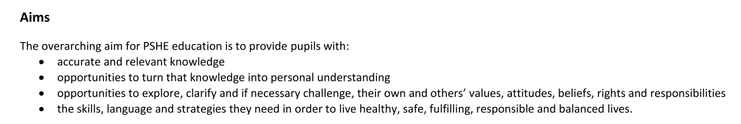
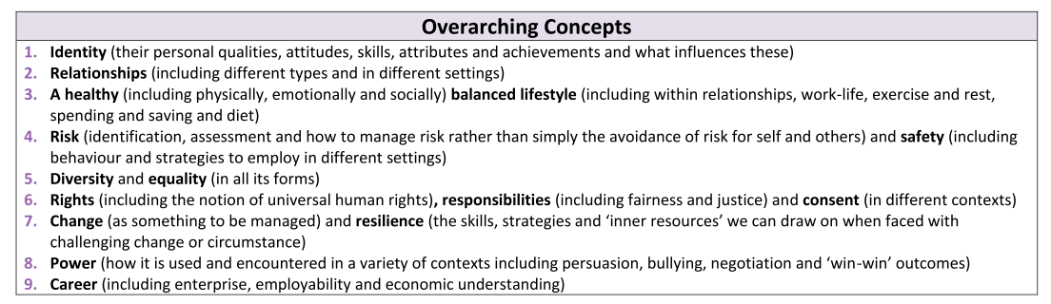
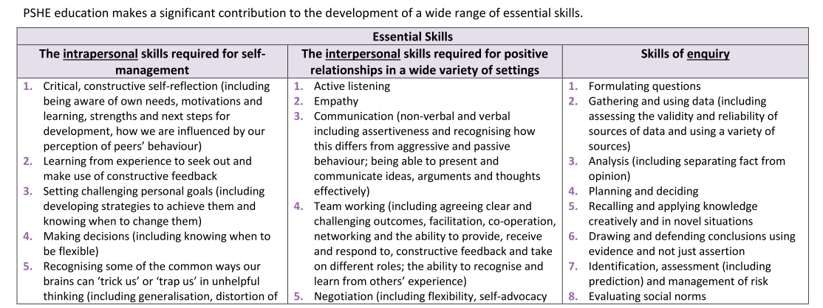
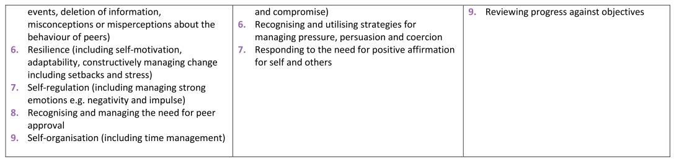
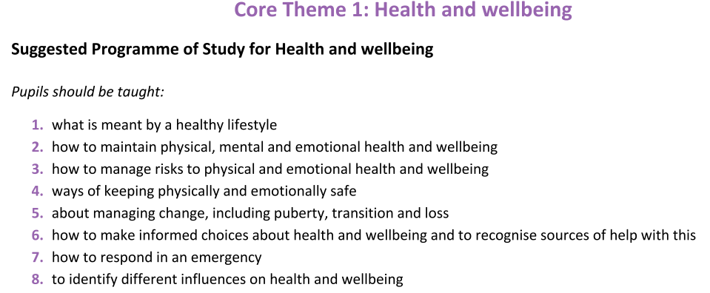
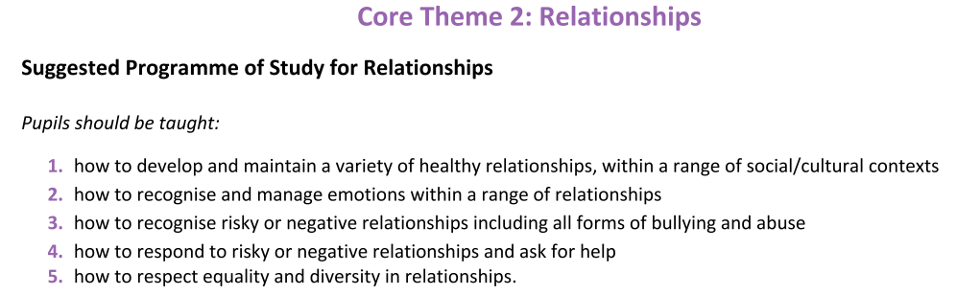
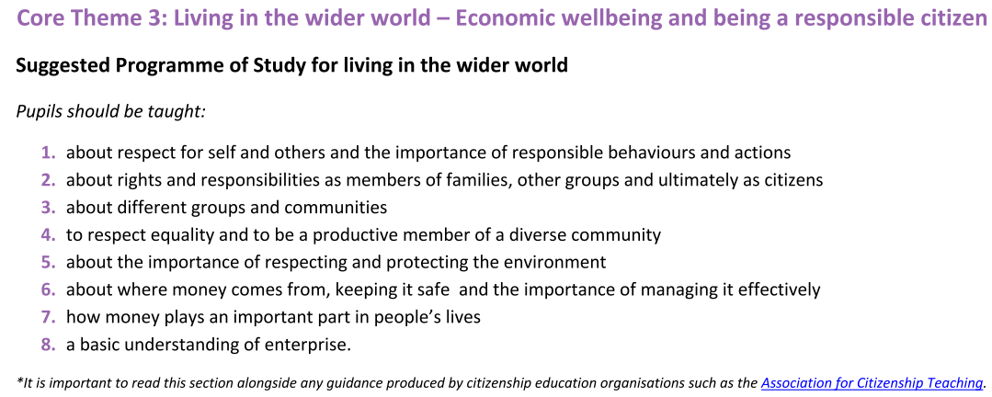
 | Health & Well-Being  PSHE Association (October 2014) | Relationships  PSHE Association (October 2014) | SRE  The Association for Science Education & PSHE Association (March 2016) | Living In The Wider World  PSHE Association (October 2014)
1 | 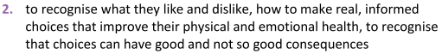 |  | Pupils should be taught to:  Identify, name, draw& label the basic parts of the human body & say which part of the body is associated with each sense  Pupils should have plenty of opportunities to learn the names of the main body parts (inc. head, neck, arms, elbows, legs, knees, face, ears, eyes, hair, mouth, teeth) through games, actions, songs & rhymes.  Vocab: head, neck, arms, elbows, legs, knees, face, ears, eyes, hair, mouth, teeth, penis, testicles, vulva | 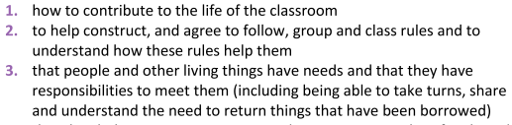
2 | 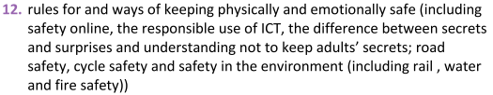  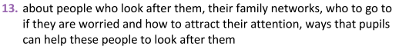 | 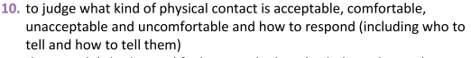 | Pupils should be taught to:  Notice that animals, inc. humans, have offspring which grow into adults (also mentioning the stages: baby, toddler, child, teenager, adult)  Describe the importance for humans of exercise, eating the right amounts of different types of food, & hygiene.  Introduced to the process of reproduction and growth in animals. The focus at this stage should be on helping pupils to recognise growth; they should not be expected to understand how reproduction occurs. The following examples might be used: egg, chick, chicken; egg, caterpillar, pupa, butterfly; spawn, tadpole, frog; lamb, sheep. Growing into adults can inc. ref. to baby, toddler, child, teenager & adult  Vocab: baby, toddler, child, teenager, adult. | 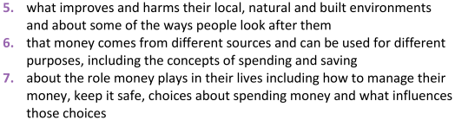
3 | 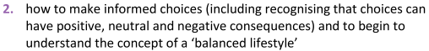 | 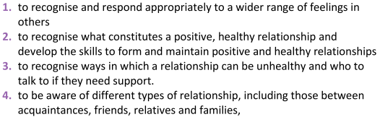 | Pupils should be taught to:  Explore the part that flowers play in the life cycle of flowering plants, inc. pollination, seed formation and seed dispersal  Vocab: pollination, pollen, male, ovule, female, seed | 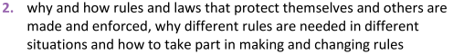
4 | 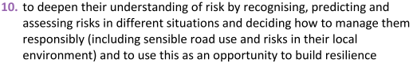  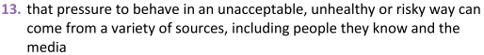  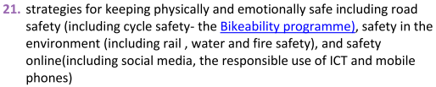 | 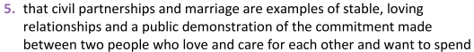  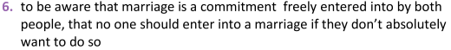 |  | 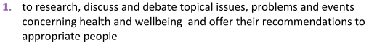  (United Nations Declaration, Rights of The Child)
5 | 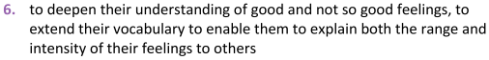  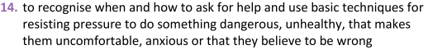  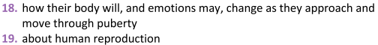 | 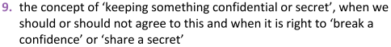  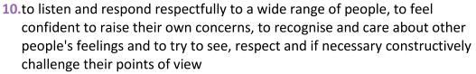  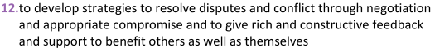 | Animals, including humans  Pupils should be taught to:  Describe the changes as humans develop to old age.  Pupils should draw a timeline to indicate changes in the growth and development of humans. They should learn about the changes experienced in puberty  Vocab: gestation period, pregnancy, live birth.  Living Things & Their Habitats  Pupils should be taught to:  Describe the differences in the life cycles of a mammal, an amphibian, an insect and a bird.  Describe the life processes of reproduction in some plants and animals.  Pupils should find out about different types of reproduction in plants, & sexual reproduction in animals.  Vocab: sexual reproduction, sperm, ovum, internal fertilisation, external fertilisation, egg, live birth, gestation period
6 | 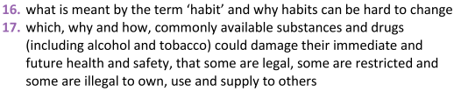  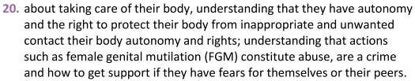 | 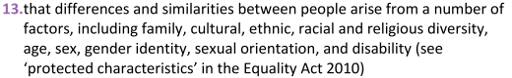  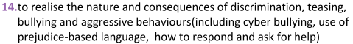  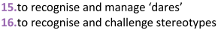 |  | 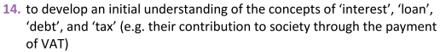  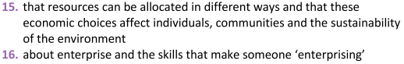

Appendix 3: RSE Questionnaire to Y5 & 6 Pupils (pre & post RSE scheme of work)
Before Relationships & Sex Education… | After Relationships & Sex Education…
Where do you get information about your body, growing up, relationships & feelings? | Did the lessons cover what you wanted to know?
Do you feel able to ask for support and advice? | Did you feel safe in the lessons?
What would you like to learn about? | What would improve the lessons for next year’s group?

