Parent View Results – Survey November 2016

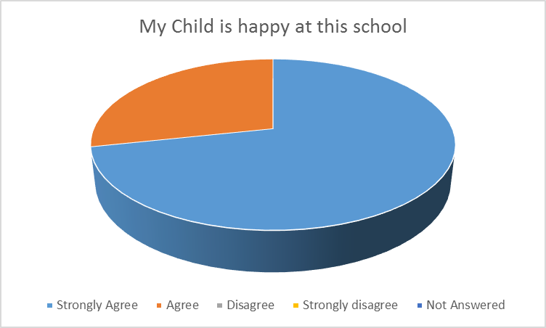
Quotes:
“The school is excellent – happy and engaged- All credit to the teachers and governing body”
“...enjoys coming to school and he is encouraged with his reading which he loves”

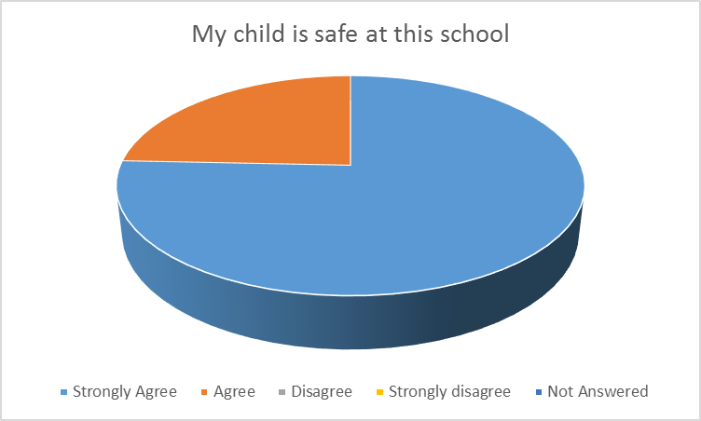
Quotes:
“I know that my children are being given amazing opportunities and are safe and happy”

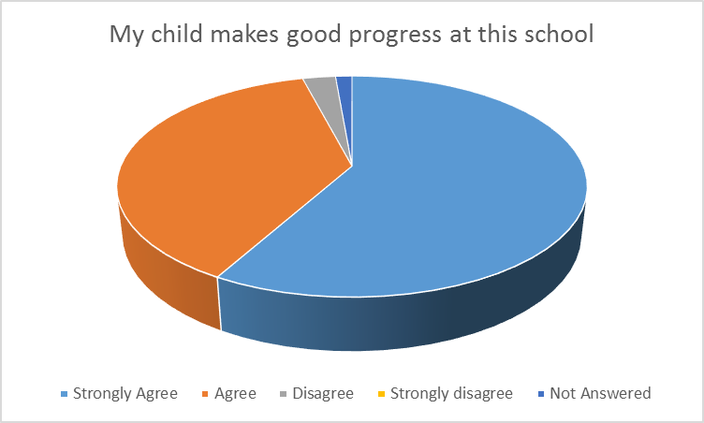
Quotes:
“...has shown really good progress with her numbers and letters”
“I am pleased at the progress of my daughter’s academic standard”
“My daughters have done very well at the school, I am very happy with it”
“Delighted with the progress and very proud of his achievement which has been driven by the help he has received from his teacher and her dedication and support”
“Love the learning ladder”
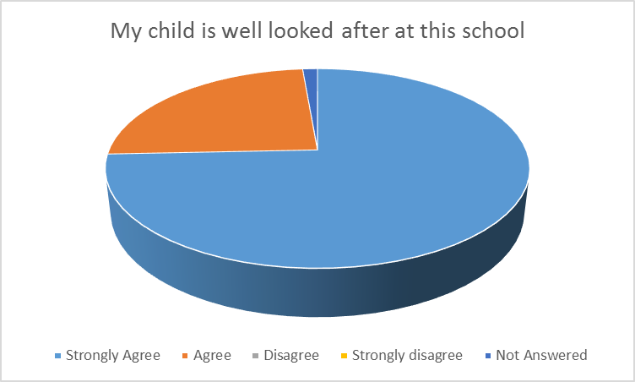

Quotes:
“Fantastic school couldn’t be happier with my child’s overall wellbeing”

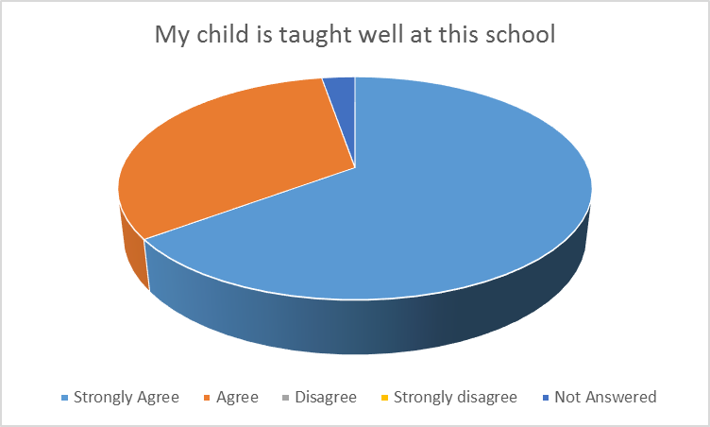
Quotes:
“The professional level of both her teachers is high. Support for these is also high”
“We are so impressed with the school, the academic focus coupled with all the other opportunities (particularly sport) are giving our child an all-round education”

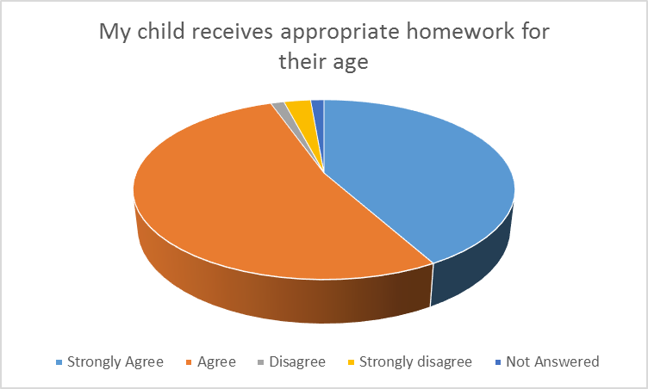

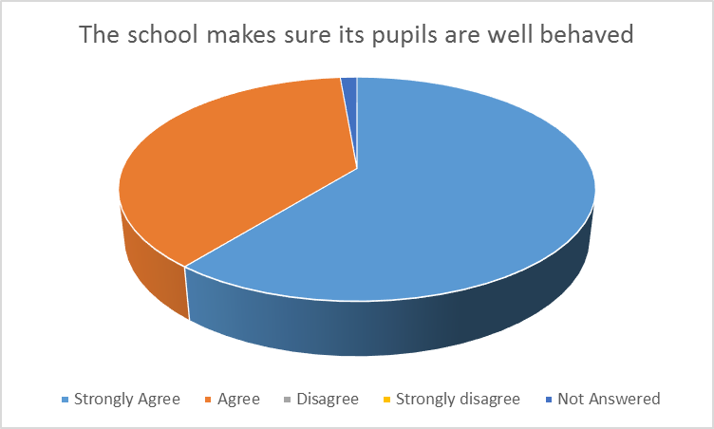
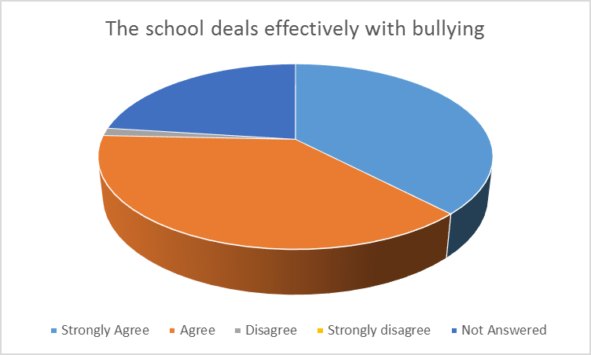

24% could not answer this question as they had not experienced or been aware of any such incidents at the school
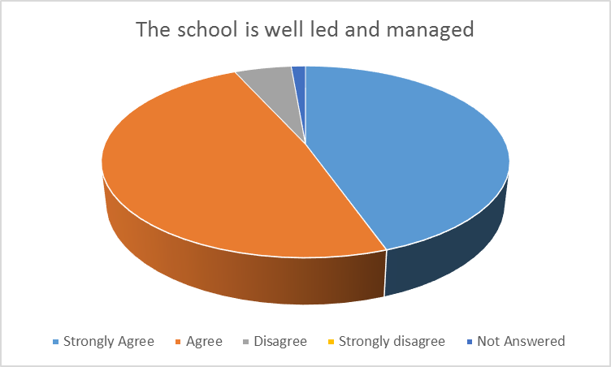

Quotes:
“We are very happy with the overall running of the school and know how hard all the staff work”
“We have seen a big improvement in the school over the past few months. Thank you to all the staff and governors for all their hard work.”
“Long period without a Headteacher in place and resulting pressure on remaining staff”
“Although the schools management is lacking due to no Headteacher, the care the children get is amazing”
“Ongoing stability required for parents and pupils”
“All the above seem to have improved dramatically recently and have noticed a huge difference in our children’s motivation”

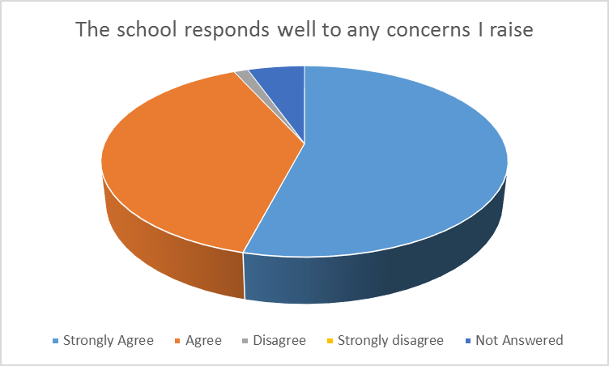

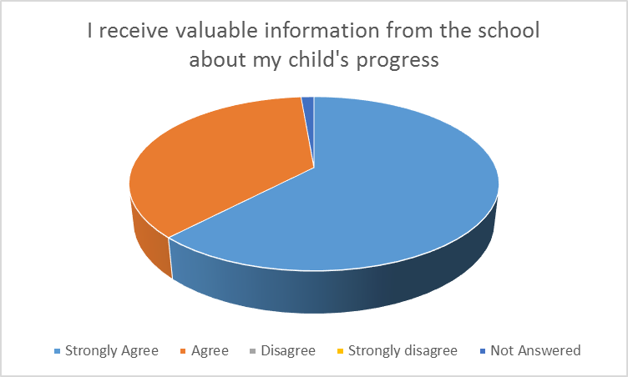

Quotes:

“The book look is enjoyable and provides the opportunity to see and discuss their work”
“Book look is great”
“Website with updates and homework by year is good”
“Good feedback on a weekly basis”
“We always receive information regarding what the children have been learning about”
“Communication so much better, great website and weekly updates are very good”
“I like getting weekly emails and the new website looks wonderful.”

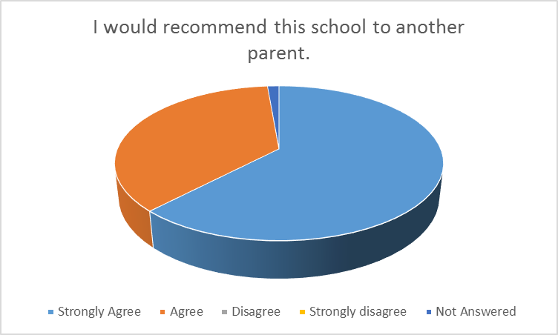

Quotes:

“I am thrilled! Very pleased with everything”.
“What are we doing well? So Much!”

Thanks to all the parents and carers for taking time to complete this form. Your input, as always, is invaluable in ensuring our school is the best it can be for our children.

